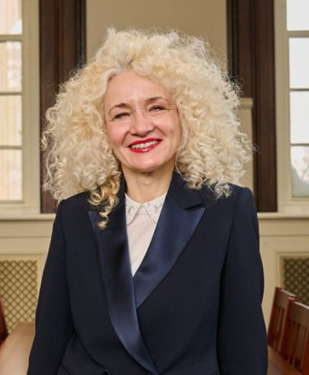Radenka Maric, *President and Board of Trustees Distinguished Professor (UConn)*

Dr. Maric was named the 17th president of the University of Connecticut by the Board of Trustees on September 28, 2022. She had served as UConn's vice president for research, innovation, and entrepreneurship since 2017. As president, she is responsible for Connecticut’s $1.5 billion public flagship university with five campuses, more than 30,000 students, and an extensive network of research and service endeavors.

Dr. Maric also holds the rank of Board of Trustees Distinguished Professor and Chair Professor in Sustainable Energy in UConn’s Departments of Chemical and Biomolecular Engineering, and Materials Science and Engineering. She formerly served as Executive Director of the UConn Technology Park and Innovation Partnership Building from 2015 to 2017.

Dr. Maric has spearheaded innovative seed-funding initiatives to support faculty early-stage research and creative work across the university. She also has developed new programs to promote interdisciplinary, multi-campus, multi-stakeholder collaborations, including: Innovation Grant in Science, Technology, Engineering, Arts, and Math (STEAM), Scholarship and Collaboration in Humanities and Arts Research Program Awards (SCHARP).

Dr. Maric is a world leader in technologies for clean energy and sustainability. She has significantly advanced understanding of materials and catalysts and has developed innovative manufacturing processes involved in fuel cell technologies, storage materials, and electrochemical sensors for health applications, leading to higher-performance, commercially viable clean energy systems.

Her scholarly work has resulted in more than 300 articles in refereed journals and conference proceedings, 21 book chapters and invited review articles in major journals, one book published, and two books under preparation. She also has six issued patents and 11 published patent disclosures. She serves on numerous review panels for the Department of Energy, the European Commission, and Horizon 2020 and serves as a board member of the International Academy of Electrochemical Energy Science.

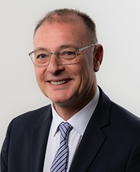

collaborators.

Pamir Alpay, *Vice President for Research, Innovation, and Entrepreneurship and Board of Trustees Distinguished Professor (UConn)*

Pamir Alpay oversees UConn’s expansive research enterprise at the main campus in Storrs, the UConn Health campus in Farmington, and the regional campuses across the state. His appointment as VPRIE followed a successful tenure as executive director of the Innovation Partnership Building at UConn Tech Park, where he served as the University’s chief advocate for industry-informed research and prime liaison between the research community and governme

Alpay is a Board of Trustees Distinguished Professor of materials science & engineering and physics and is an elected member of the Connecticut Academy of Science & Engineering (CASE). He is a Fellow of the American Physical Society, ASM International, and the American Ceramic Society.

Alpay earned his B.S. and M.S. from Middle East Technical University in Ankara, Turkey, and his Ph.D. from the University of Maryland.

Lindsay DiStefano, *Associate Vice President for Research Development (UConn)*

Lindsay DiStefano is UConn’s associate vice president for research development and a professor in the department of kinesiology. Prior to her appointment as AVP, she served as the head of the department of kinesiology. She has affiliate appointments in the department of public health sciences and the department of orthopedic surgery in the UConn School of Medicine.

DiStefano is extremely active in kinesiology research, where she works to determine the best strategies to promote physical literacy and reduce the risk of youth sports-related injuries.

DiStefano has published numerous research papers and presented nationally and internationally. She is currently engaged with major research studies to identify best practices for implementation and dissemination of interventions to improve safe physical activity participation and ensure proper development of physical literacy in children. DiStefano completed her undergraduate degree at Boston University and her graduate and doctoral degrees at the University of North Carolina at Chapel Hill.

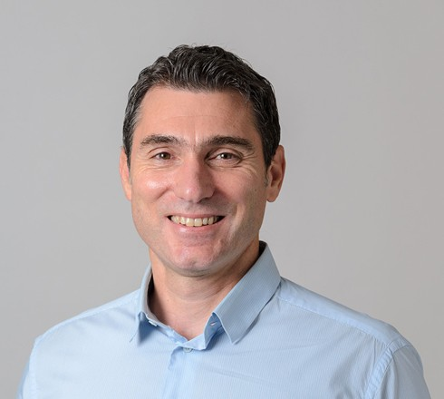Manos Anagnostou, *Director, Eversource Energy Center and Board of Trustees Distinguished Professor (UConn)*

Dr. Anagnostou is a Professor in the Department of Civil and Environmental Engineering and the Eversource Energy Endowed Chair in Environmental Engineering. He is the Director of the newly established Eversource Energy Center (eversource.uconn.edu) and one of the Applied Research Directors of the Connecticut Institute for Resilience and Climate Adaptation (circa.uconn.edu). Dr. Anagnostou’s

research efforts focus on remote sensing of water cycle and integrating earth observations with models for improving water cycle predictability at global scale. He is exploring severe weather events and leveraging advanced technologies to predict the impact on communities and the natural and built environment (roadways, buildings, power grids and water infrastructure). His research directly benefits society and neighborhoods globally. He is dedicated to inspiring the current generation of students and researchers who will pave the way and innovate scientific research and technologies to secure society during climatic extremes.

He participates in several networks of scientists planning satellite precipitation measurement missions and international research projects on precipitation and hydrological extremes. He has been recognized with prestigious international prizes and awards including the Plinius Medal by the European Geophysical Union, the Marie Currie Excellence Award by the European Commission and the UCONN Alumni Association Excellence-in-research award. He has supervised 22 graduate students (12 Ph.D.) and mentored 6 Postdoctoral Scholars. He is currently advising 10 graduate students. His work has been published in over 140 journal papers, 7 book chapters, and a number of conference proceedings. He is currently PI on multiple research grants totaling over 8 M$.

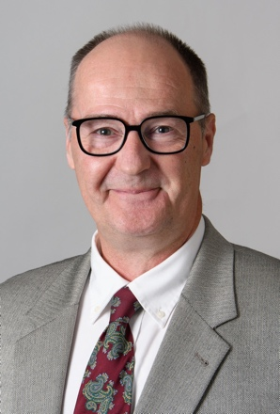Mark Aindow, *Professor Department of Material Science and Engineering (UConn)*

Dr. Aindow is a Professor of Materials Science and Engineering (MSE) at the University of Connecticut (UConn). He was educated at the University of Liverpool in England, receiving a BEng in Metallurgy and Materials Science in 1985 and a PhD in Materials Science and Engineering in 1988. He spent two years as a Postdoctoral Research Fellow at Case Western Reserve University and then at The Ohio State University. His first faculty appointment was from 1990-1999 in the School of Metallurgy and Materials at The University of Birmingham, England.

Aindow joined the faculty at the UConn in 1999. He was the Director of the MSE Program from 2006-2009, Associate Director for the Institute of Materials Science from 2013-2017, and Executive Director for Innovation, External Engagement and Industry Relations in the Office of the Vice President for Research from 2018-2023. He held sabbatical appointments as a Visiting Professor in the MSE Dept. at National Taiwan University, Taipei in 2005, and as a Visiting Fellow in the Dept. of Applied Physics at Yale University in 2012. He served as Deputy Editor- in-Chief for the Journal of Materials Science from 2008-2017.

Aindow’s research focuses on microstructural development in engineering materials, with particular emphasis on analysis using electron-, ion- and X-ray beam instruments. He has published 270 journal papers and 160 papers in refereed conference proceedings.

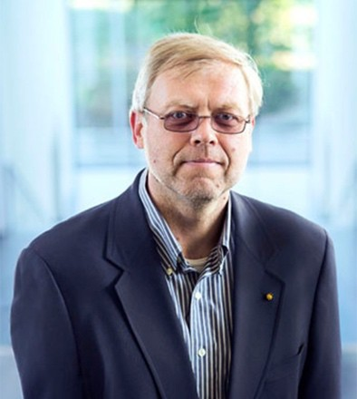Alexander Balatsky, *Professor Department of Physics (UConn)*

Dr. Balatsky is a distinguished physicist known for his work in condensed matter theory. He received his MSc from the Moscow Physical-Technical Institute and his PhD from the Landau Institute for Theoretical Physics. Balatsky has held academic and research positions at the University of Illinois, Los Alamos National Laboratory, and NORDITA. His research has significantly contributed to the understanding of high-temperature superconductivity, Dirac materials, and quantum criticality. Balatsky is recognized as a Fellow of both the American Physical Society and the American Association

for the Advancement of Science, and he has received numerous awards for his contributions to physics.

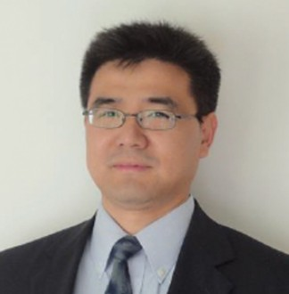Yang Cao, Professor Department of Electrical and Computer Engineering (Uconn)

Dr. Yang Cao is a full professor at the Department of Electrical and Computer Engineering and the director of the Electrical Insulation Research Center of the University of Connecticut. His research interests are in the physics of materials under extreme conditions and the development of new dielectric materials, particularly the polymeric nanostructured materials, for energy efficient power conversion and renewables integrations, as well as for novel medical diagnostic imaging devices. He is currently co-directing the NSF iUCRC Center on High Voltage/ Temperature and serving as the PI for multiple projects funded

by DOE/ARPA-e, ONR, NSF, NASA, as well as by many industrial partners.

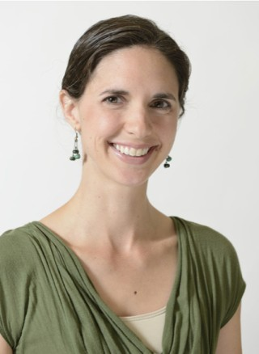Lesley Frame, Assistant Professor Department of Materials Science & Engineering (UConn)

Lesley Frame is Assistant Professor of Materials Science and Engineering, UTC Professor of Innovation, and Director of the Center for Materials Processing Data at the University of Connecticut. Dr.

Frame received her BS from the Department of Materials Science Engineering at MIT, and she received her MS and PhD from University of Arizona in the same ﬁeld. Upon completion of her Ph.D. she held postdoctoral positions at The Arizona Research Institute for Solar

Energy, and then at CardiG University and the Rutherford Appleton Laboratory as a Fulbright Scholar where she studied residual stresses using neutron diGraction. Dr. Frame spent ﬁve years in industry at Thermatool Corp. leading product development projects, the materials characterization lab, customer technical training seminars, and process improvement eGorts for the tube and pipe industry. Her current research is focused on materials processing-structure-property relationships and failure analysis related to metals manufacturing processes, residual stress formation, corrosion, and transient materials properties. She is actively involved in ASM International, and she is a past President of the Heat Treating Society, and she is the Vice President for the International Federation for Heat Treatment and Surface Engineering (IFHTSE).

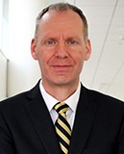Rainer Hebert, *Director of Pratt and Whitney Additive Manufacturing Center. Associate Director, Institute of Materials Science, and Professor Department of Materials Science and Engineering (UConn)*

Dr. Hebert attended the University of Saarbrücken, Germany, and graduated in 1997 with a Diplom in physics. He then switched fields and graduated with a Ph.D. in Materials Science and Engineering from the University of Wisconsin-Madison in 2003. Following stints as a post-doc at the Institute of Nanotechnology, Karlsruhe Research Center, Germany, and at the University of Wisconsin-Madison, he

joined the University of Connecticut in 2006.

Dr. Hebert’s research interest focuses on rapid solidification of metallic materials. Aside from a long-standing interest in metallic glasses, Dr. Hebert has more recently turned his attention to additive manufacturing of metallic materials. He spent a year on sabbatical in the additive manufacturing group at Pratt & Whitney and upon returning to UConn assumed the role of director of UConn’s Additive Manufacturing Center, which he led since 2012. In this position he oversees research and development projects with industry sponsors and expands the Center’s capabilities for additive manufacturing materials research. Dr. Hebert serves in addition as associate director of the Institute of Materials Science at UConn. Dr. Hebert is a Fellow of ASM and a member of the CT Academy of Science.

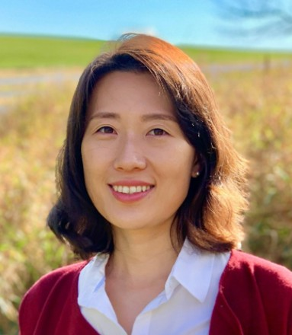SeungYeon Kang, Assistant Professor Department of Mechanical Engineering (UConn)

Dr. SeungYeon Kang is an assistant professor in the School of Mechanical, Aerospace and Manufacturing Engineering at the University of Connecticut. She earned her B.A. in Chemical Engineering from Cornell University and her Ph.D. in Applied Physics from Harvard University. Following her graduate studies, she served as a senior research engineer at Samsung SDI, focusing on lithium-ion batteries, and later worked as a

postdoctoral research associate at Princeton University. Before joining the faculty at UConn, she was the program manager for the NSF SHAP3D additive manufacturing center at the university. Her current research interests encompass advanced laser materials processing techniques, the fundamental principles and applications of light-matter interaction, stereolithography, 3D nanofabrication, and energy storage technology.

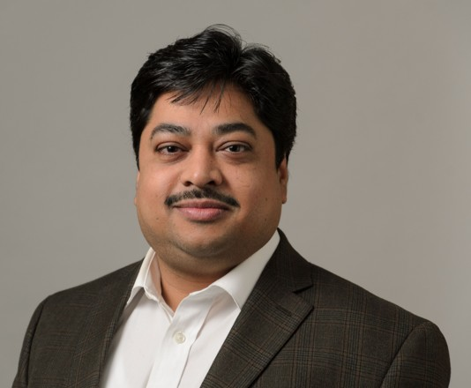 Sanjeev K. Nayak, *Research Scientist Department of Materials Science & Engineering (UConn)*

As a Research Scientist at the Department of Materials Science & Engineering at the University of Connecticut, Dr. Nayak applies theoretical condensed matter physics methodologies, including quantum theory and many-body theory. His research focuses on deciphering intricate structure-property relationships, predicting design rules for developing smart materials, and exploring their

applications in current and future technologies.

Dr. Nayak earned his PhD in Physics from the University of Duisburg-Essen, Germany. Prior to his current position, he served as a research associate at Martin Luther University Halle- Wittenberg, Germany. During this time, he contributed to a collaborative research project on the Functionality of Oxide Interfaces, working closely with the Max Planck Institute of Microstructure Physics and the University of Leipzig.

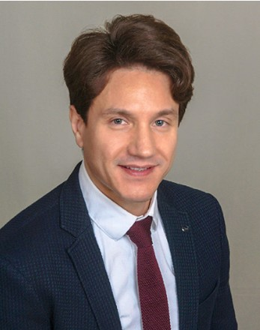Volkan Ortalan, Associate Professor Department of Material Science and Engineering (UConn)

Dr. Volkan Ortalan is an Associate Professor in the Materials Science and Engineering at the University of Connecticut. He received his Ph.D. from the University of California-Davis in 2010. Ortalan has been a postdoctoral scholar at Physical Biology Center for Ultrafast Science and Technology at California Institute of Technology working

with Nobel Laureate Ahmed Zewail and a visiting graduate student researcher at the Advanced Microscopy Laboratory at the Oak Ridge National Laboratory. He won the Office of Naval Research Young

Investigator Program Award in 2016. His research interests include the development of ultrafast transmission electron microscopy and the application of ultrafast and in-situ TEM techniques to study phase and structural transformations, materials under extreme conditions, laser-induced dynamics of nanomaterials, and the application of high-resolution in-situ TEM for nanoscale materials employed as heterogeneous catalysts.

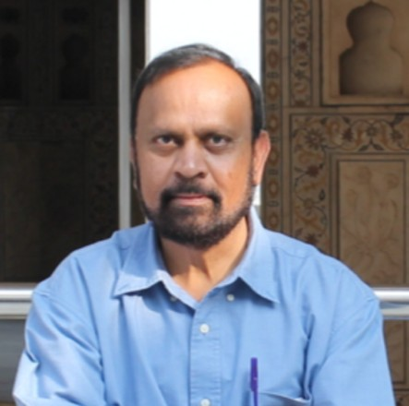Sanguthevar Rajasekaran, Director of the School of Computing, Board of Trustees distinguished professor

Sanguthevar Rajasekaran received his M.E. degree in Automation from the Indian Institute of Science (Bangalore) in 1983, and his Ph.D. degree in Computer Science from Harvard University in 1988. Currently he is the Director of the School of Computing, Board of Trustees Distinguished Professor, and Pratt & Whitney Chair Professor of CSE at the University of Connecticut. Before joining UConn, he has served as a faculty member in the CISE Department of the University of Florida and in the CIS Department of the University of Pennsylvania. During 2000-2002 he was the Chief Scientist for Arcot Systems. His research interests include Big Data, AI and Machine Learning, Quantum Computing, Bioinformatics, Algorithms, Data Mining, Randomized Computing, and HPC. He has published over 350 research articles in journals and conferences. He has co-authored two texts on algorithms and co-edited six books on algorithms and related topics. He has been awarded numerous research grants from such agencies as NSF, NIH, US Census Bureau, CIA, DARPA, Industry, and DHS (totaling more than $22M). He is a Fellow of the Institute of Electrical and Electronics Engineers (IEEE), the American Association for the Advancement of Science (AAAS), the American Institute for Medical and Biological Engineering (AIMBE), and the Asia-Pacific Artificial Intelligence Association (AIAA). He is also an elected member of the Connecticut Academy of Science and Engineering.

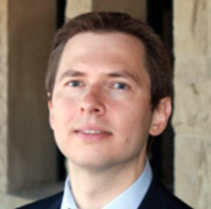Ilya Sochnikov, Assistant Profesor Department of Physics (UConn)

Dr. Sochnikov obtained his PhD in 2012 from the Physics Department and Institute for Nanotechnology at Bar-Ilan University. He continued his research from 2012 to 2015 at Stanford University in the Geballe Laboratory for Advanced Materials. He then joined UConn as a faculty member in 2016. His interests focus on quantum magnetic imaging, sensing, superconducting electronics, unconventional

superconductors, magnetic and topological materials, as well as strain tuning of material properties.

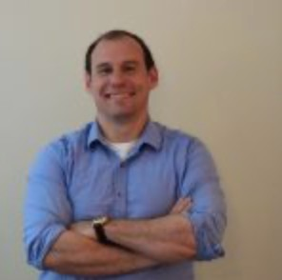Carlos Trallero, Professor Department of Physics (UConn)

Prof. Carlos Trallero is a full professor in the Department of Physics at the University of Connecticut. His areas of interest are broad, with a focus on dynamical studies of laser-matter interaction. Some of the recent topics include atto and zeptosecond science and their application to dynamical mapping of phase and amplitude measurements of quantum states in atoms, nanoparticles, and heterogeneous 2D materials. On the latter topic, we are currently studying exciton and polariton formation, control and interaction with applications to quantum

information sciences and sensing.

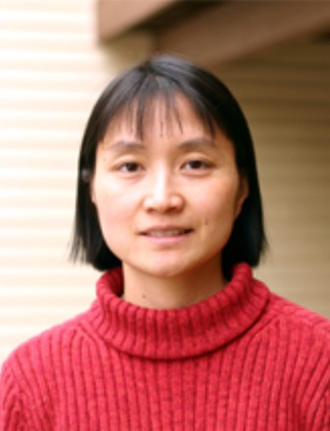Bing Wang, Professor School of Computing (UConn)

Bing Wang is a Professor of School of Computing. Her research area is broadly in distributed systems and computer networks. Recently, she has been designing eGicient algorithms for quantum computer networks to support a broad range of quantum applications, including quantum key distribution, distributed quantum computing, and quantum sensing.

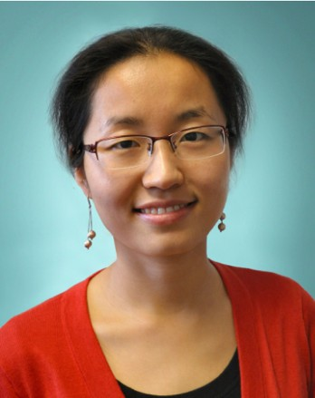Xinyu Zhao, Associate Professor Department of Mechanical Engineering (UConn)

Prof. Xinyu Zhao is the Centennial term associate professor at University of Connecticut. She joined the School of Mechanical, Aerospace and Manufacturing in Spring 2015 as an assistant professor, and prior to that, she was a postdoctoral research fellow in Combustion Energy Frontier Research Center at Princeton (2014), co-sponsored by Sandia National Laboratory and Pennsylvania State University. She received her Ph. D. degree in

Mechanical Engineering from Pennsylvania State University (2013), and she received her Bachelor’s and Master’s degrees in Thermal Engineering from Tsinghua University in 2006 and 2008, respectively. Prof. Zhao’s research program is supported by NSF CISE, the American Chemical Society Petroleum Research Fund, NASA, NSF C-BET, AFOSR, and ONR. She has also been actively working with industrial partners such as FM Global, Pratt&Whitney and Raytheon Technologies Research Center. Prof. Zhao is the recipient of the AFOSR YIP award, NSF CAREER award, and Combustion institute’s Irvin Glassman Young Investigator award. Her research interest includes detailed radiation modeling for multiphase combustion systems, turbulent combustion modelling, detonation, the interplay between experiments and computation, as well as high-performance computing.

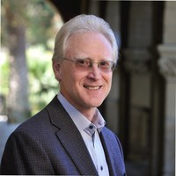David L. Clark*, Laboratory Fellow (LANL)*

David L. Clark is the Director of the Los Alamos National Laboratory’s National Security Education Center. He received a Ph.D. in chemistry in 1986 from Indiana University. He was a postdoctoral fellow at the University of Oxford before joining Los Alamos National Laboratory as a J. Robert Oppenheimer Fellow in 1988. He became a Technical Staff Member in the Isotope and Nuclear Chemistry Division in 1989.

Clark served as inaugural Director of the Glenn T. Seaborg Institute for Transactinium Science between 1997-2009. He has served the DOE as a technical advisor for environmental stewardship including the Rocky Flats cleanup and closure (1995- 2005), closure of High-Level Waste tanks at the Savannah River Site (2011), and as a technical advisor to the DOE High Level Waste Corporate Board (2009-2011). He was the program manager for plutonium aging and pit lifetime assessments, and Capture Manager for the Plutonium Science and Research Strategy at Los Alamos. He is a Fellow of the American Association for the Advancement of Science, and a Los Alamos Laboratory Fellow. He is the recipient the ACS Nobel Laureate Signature Award (1988) and the ACS Glenn Seaborg Award in Nuclear Chemistry (2017). He has also been honored with several Defense Programs Awards of Excellence. His research interests are in the molecular and electronic structure of actinide materials, applications of synchrotron radiation to nuclear security, behavior of actinide and fission products in the environment, the aging effects of nuclear weapons materials, and the education of judges on the methods of science. He is an international authority on the chemistry and physics of the actinides, and has published over 180 peer-reviewed publications, encyclopedia and book chapters.

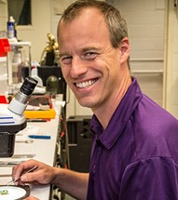Filip Ronning, *Director Institute for Material Sciences (LANL)*

Filip Ronning is the Director of the Institute of Materials Science at Los Alamos National Lab. He received a B.A. in Physics from Cornell University in 1996 and a Ph.D. from Stanford University in 2001 for angle resolved photoemission work on strongly correlated oxides. Following two years at the University of Toronto he joined Los Alamos National Lab in 2003 as a Reines postdoctoral fellow. His scientific interests include (but are not limited to) topological matter, quantum spin systems, heavy-fermion physics,

unconventional superconductivity, quantum criticality, low-dimensional physics, spin-orbit coupled systems, and new states of matter. He leads a DOE-Basic Energy Sciences program on f- electron compounds, and is the co-design lead for topologically protected quantum information in the Quantum Science Center. A LANL distinguished mentor, in 2015 he was elected fellow of the American Physical Society, in 2023 he became a fellow of Los Alamos National Lab, and he currently serves as a Divisional Associate Editor for PRL. In his free time he enjoys spending time with his family and playing any sport his body still permits.

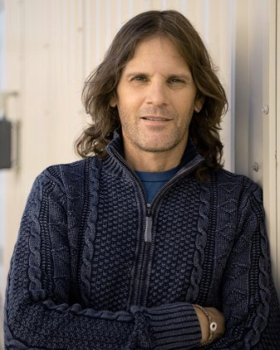John Bernardin, *Technical Staff Member, Engineering Technology & Design, (LANL), President and Owner: Engineering & Technology Instruction, LLC and Adjunct Professor at University of New Mexico*

Dr. Bernardin is currently a Team Leader and R&D Mechanical Engineer at Los Alamos National Laboratory (LANL). He is currently the Project Leader of ten R&D projects (> $13M annually) in the areas of Additive Manufacturing (AM), Advanced Sensing and Diagnostics, and Optical Scanning. Dr. Bernardin is also the director of the E-2 Additive Manufacturing and Prototyping Laboratories, consisting of more than three dozen AM machines (aka 3D printers), various AM material production and characterization

systems, and numerous optical scanning/inspection stations. Under his guidance and direction, the AM and Prototyping Laboratories have developed unique technological hardware, new AM materials and processes, and new AM embedded sensing methods for temperature, strain, radiation, and gas measurement techniques. Through this AM research initiative he has produced more than 50 publications, given numerous invited talks to US DOE laboratories, mentored 50+ students and engineers, and has produced five patents. Dr. Bernardin is also the LANL lead for the development of the LANL Advanced Center for Manufacturing Excellence.

Dr. Bernardin also manages three experimental laboratories devoted to thermal-flow visualization experimentation, general mechanical engineering measurements, and electro-mechanical prototype assembly and testing.

Dr. Bernardin is a Fellow of the American Society of Mechanical Engineers, the President and Owner of and engineering consulting company, Engineering and Technology Instruction, LLC, and is also an Adjunct Professor with the University of New Mexico.

Previously at LANL, Dr. Bernardin served as a Senior Mechanical Design and Test Engineer for NASA’s Mars Science Lab ChemCam Instrument, NASA’s Dawn GRaND instrument, NASA’s Interstellar Boundary Explorer and Gamma Ray/Neutron Detector, and DARPA’s XNAV X-ray telescope. He has also served as a design team member on the Sample Collection Investigation of Mars spacecraft, the U.S. DOD’s Global Burst Detection and Deep Space programs, and several other space exploration programs. In addition, Dr. Bernardin has served as both a research/design engineer during the design and construction phases of several World-Class facilities critical to the research and defense missions of the United States. His design teams were responsible for the design of thermal control and vacuum systems on the linear particle accelerator for the Spallation Neutron Source, upgrades to the LANSCE Drift Tube Linear Accelerator Water Cooling System, the laser conditioning optics for the National Ignition Facility, the storage vaults for LANL’s Nuclear Materials Storage Facility, the solid-state vertex detector for the Relativistic Heavy Ion Collider’s PHENIX Experiment, and numerous environmental testing stations for national security missions. Over the past 28 years at LANL, Dr. Bernardin has served in multiple engineering roles encompassing mechanical design, numerical modeling, and experimental testing. Dr. Bernardin has authored over 140 scientific and engineering papers in the refereed literature and more than 70 other publications covering a wide range of engineering and scientific topics including advanced manufacturing, thermal sciences, optics, surface chemistry, cryogenics, vacuum science and technology, materials processing, electronic cooling, boiling and radiation heat transfer, two-phase flow; and space- based detection techniques and technologies. During his tenure at LANL, Dr. Bernardin and his associated teams have been awarded over $115M in research investments.

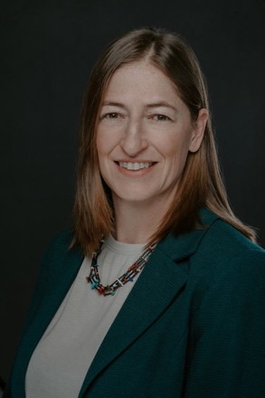Abbie Hunter, *Group leader of the Materials and Physical Data group (LANL)*

Dr. Abigail Hunter is currently the group leader of the Materials and Physical Data group within the Computational Physics (XCP) Division at Los Alamos National Laboratory (LANL). She is also the project leader for the Materials Physics project within the Advanced Simulation and Computing (ASC), Physics and Engineering Models (PEM) Program, and the Deputy Director for the Institute of Materials Science at LANL. She earned a Ph.D. in Mechanical Engineering from Purdue University in 2011, and a B.S. degree in Mechanical Engineering from the University of Utah

in 2006. Following her Ph.D., she joined LANL as a postdoctoral research associate in 2011 and converted to a staff scientist in 2012. In 2020, she received the Alum of the Year Award from the Department of Mechanical Engineering at the University of Utah in recognition for outstanding achievements in Mechanical Engineering and service to the community. In 2019 she was nationally recognized as a recipient of the Presidential Early Career Award for Scientists and Engineers (PECASE) for work developing and implementing models addressing brittle damage and dislocation dynamics in metals, which are two capabilities designed to address questions concerning advanced manufacturing of new materials. She is the Editor-in-Chief for ASME's Journal of Engineering Materials and Technology and an Associate Editor for the International Journal of Plasticity. Her research interests include modeling the strength and damage of metals at both the meso- and macro-scales, with specific interest in connections between microstructure, dislocation-based deformation behaviors, and overall material response.

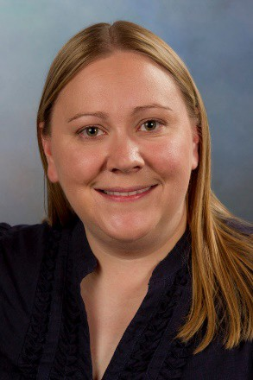Amy J. Clarke, *Science-based Advanced Manufacturing of Metals and Alloys (LANL)*

Amy J. Clarke is a Distinguished Scientist in the Sigma Manufacturing Science Division at Los Alamos National Laboratory and holds a faculty joint appointment with the Department of Metallurgical and Materials Engineering (MME) at the Colorado School of Mines (Mines). Previously, she was the John Henry Moore Distinguished Professor of Metallurgical and Materials Engineering in MME at Mines. Amy currently serves as Director of a multi-university, National Nuclear Security Agency (NNSA)

Stewardship Science Academic Alliances Center of Excellence on Advanced Characterization of Metals under Extreme Environments. Her research focuses on physical metallurgy; making, measuring, and modeling metallic alloys during processing to realize advanced manufacturing; and processing-structure-properties-performance relationships in metals and alloys. Amy received her MS and PhD degrees from Mines and her BS degree at Michigan Technological University in Metallurgical and Materials Engineering. She serves on The Minerals, Metals & Materials Society (TMS) Foundation Board of Trustees, as an Editor for Metallurgical and Materials Transactions A, and has served on the TMS and Association for Iron & Steel Technology Boards of Directors. She is a past recipient of a Presidential Early Career Award for Scientists and Engineers (nominated by the U.S. Department of Energy (DOE) and NNSA Defense Programs), U.S. DOE Office of Science Early Career Research Program, Office of Naval Research Young Investigator Program, and Mines Excellence in Research Award (Senior). She is also a TMS Brimacombe Medalist and Fellow of ASM International.

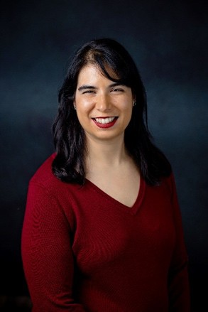Amber N. Black, *Research and Development Engineer (LANL)*

Dr. Amber N. Black is a Research and Development Engineer for Los Alamos National Laboratory (LANL). She is a part of Sigma division which is the laboratory’s manufacturing science group as part of the Welding & Joining team. She is the subject matter expert on high energy density welding and electron beam additive manufacturing. She has worked with lasers and electron beams for over 18 years, using them to weld, cut, drill, braze, engrave, coat, and for various research processing methods. Dr. Black is the principal investigator for a number of high priority projects and the author of numerous reports and presentations, which are

instrumental to supporting stockpile stewardship and modernization as part of LANL’s mission. Prior to joining LANL she worked as a Welding Applications Engineer for PTR – Precision Technologies, where she developed welds for customers in aerospace, defense, automotive, research, and industrial applications.

She has been a member of the materials science community for 20 years. Amber is a Board Trustee for ASM International, a subcommittee chair for the American Welding Society (AWS), and a US delegate to the International Institute of Welding (IIW). In these positions she has been instrumental in standards development, co-authored handbook chapters, and acted as chair for a number of committees and subcommittees

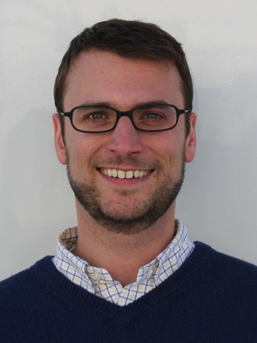Blake Sturtevant, *Team Leader Shock & Detonation Physics group (LANL)*

Blake Sturtevant received an A.B. in Physics from Bowdoin College in 2003 and earned a Ph.D. in Physics from the University of Maine in 2009. He joined Los Alamos National Laboratory in 2010 as a postdoc in the Materials Physics and Applications (MPA) Division, working to develop a high temperature (250°C), high pressure (3000 psi) ultrasound-based tool for characterizing Enhanced Geothermal Systems. In 2013, Blake was hired as a Staff Scientist in Materials Physics and Applications.

In 2018, Blake joined the Shock & Detonation Physics group as a member of the Static High Pressure Team, and became the Team Leader in early 2019. While Blake is involved in all of the scientific activities of the team, his recent principle research efforts have focused on on large volume press (Paris-Edinburgh style) and dynamic diamond anvil cell experiments, to study material elasticity at high P/T conditions and the kinetics of phase transitions, respectively. The majority of Blake’s experiments are performed at synchrotron light sources such as HPCAT (Advanced Photon Source, Argonne National Lab) and the Extreme Conditions Beamline (PETRA-III at DESY in Hamburg, Germany). Blake’s Team received a LANL Distinguished Performance Award and an NNSA Defense Programs Award of Excellence, both in 2019, for their research into the properties of plutonium at high pressure.

In addition to his technical work, Blake has been the Deputy Group Leader of the Shock & Detonation Physics Group since 2021.

Candace Culhane, *Project/Program Director (LANL)*

Ms. Culhane is a Project/Program Director for Los Alamos National Laboratory, where she is the Quantum Science Coordinator, working to strengthen and grow the LANL workforce in quantum information sciences through education and training and the enhancement of inter-laboratory, industrial and academic partnerships. Prior to joining LANL, Ms. Culhane was with the Department of Defense, where she was a program manager on multiple projects to stimulate the creation of commercial supercomputers. She was elevated to the Senior Executive Service

in 2008 and her last position before retirement was Deputy for Future Computing at the Laboratory for Physical Sciences. She is a Senior Advisor to the Council on Competitiveness, a member of the steering committee for the ACM/IEEE SC conference series, Treasurer for IEEE Quantum TC, co-founder of the IEEE Conference on Quantum Computing and Engineering, and is the General Chair for the 2024 International Conference for Quantum Computing and Engineering.

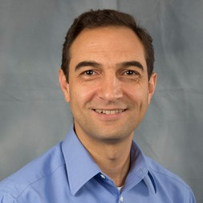Hashem Mourad, *Group Leader of the Fluid Dynamics and Solid Mechanics Group (LANL)*

Hashem Mourad is the Group Leader of the Fluid Dynamics and Solid Mechanics Group, which constitutes part of Theoretical Division at Los Alamos National Laboratory. In recent years, he has served in multiple project leadership roles under the DoD/DOE Joint Munitions Program (JMP) and the Laboratory- Directed Research and Development (LDRD) program. His research work centers on the modeling of complex, nonlinear behaviors in solid materials, and on the development of the

computational and data science methods needed to implement such models and employ them in simulations aimed at answering questions of interest to the solid/structural mechanics and materials science communities. His technical contributions over the years at LANL include multiscale models and specialized finite element methods for adiabatic shear localization problems, phase-field models and computational techniques for dynamic fracture problems, and dislocation flux-based single crystal plasticity models. Hashem holds a PhD in Mechanical Engineering from the University of Michigan (2004), and BS and MS degrees in Engineering from the American University in Cairo.

Nicholas A. Dallmann, *LANL*

Nicholas Dallmann received a BS in Computer Engineering from Purdue University, West Lafayette. He received a MS and PhD in Electrical Engineering from Arizona State University, Tempe with focus in semiconductor physics and electromagnetics. Since 2002, Nick has been staff at Los Alamos National Laboratory. He spent years in the Los Alamos space instrumentation, physics, and now materials physics and applications divisions. His work has mostly related to novel remote sensing solutions for both terrestrial and space based national security applications. His research interests include quantum optics for sensing, computing, and communications